**Physiological mismatches predict competitive outcomes among phytoplankton**

Elvire Bestion1*, Bernardo Garcia-Carreras2, Charlotte-Elisa Schaum1, Samraat Pawar2, Gabriel Yvon-Durocher1*

1Environment and Sustainability Institute, University of Exeter, Penryn, Cornwall TR10 9EZ, UK

2 Department of Life Sciences, Imperial College London, Silwood Park Campus, Ascot, Berkshire, SL5 7PY, UK

*correspondence to [e.bestion@exeter.ac.uk](mailto:e.bestion@exeter.ac.uk), [g.yvon-durocher@exeter.ac.uk](mailto:g.yvon-durocher@exeter.ac.uk)

# Abstract

**Keywords:** nutrients, phosphate, global changes, climate change, interspecific competition, trait-based ecology

# Introduction

In a context of global changes, the increase in the number of invasive species, as well as the rising water temperatures, are threatening freshwater ecosystems (Woodward, Perkins & Brown 2010; Gallardo *et al.* 2016). These two threats can act in synergy as climate change is believed to increase the likelihood of the survival, establishment, growth, and spread of invasive populations (Field, Barros & Intergovernmental Panel on Climate Change 2014). In freshwater systems, changes in the frequency of high-flow events and increases in water temperature can benefit the establishment of alien species and as a result affect local species interactions (Rahel & Olden 2008). Climate change is predicted to be a major cause of species extinctions over the next century (Field *et al.* 2014), and a considerable threat to biodiversity (Thomas *et al.* 2004; Bellard *et al.* 2012). Susceptibility to climate change will depend on species traits (Pacifici *et al.* 2015). For instance, species occupying narrower thermal niches are believed to be more vulnerable to climate change (Magozzi & Calosi 2015). However, recent studies have highlighted that species interactions may play a greater role in mediating the impacts of climate change on populations than physiological tolerance limits (; Cahill *et al.* 2013; Field *et al.* 2014). A review of 688 studies found that climate change affects various types of species interactions, including competition (Tylianakis *et al.* 2008). To better predict the consequences of future climate change, it is thus crucial to understand how increased temperatures affect species interactions.

One avenue for research is the study of how species traits can affect competition between species (Reuman, Holt & Yvon-Durocher 2014). For instance, in freshwater fishes, a global trait meta-analysis found that invasive species were generally characterised by larger body sizes, greater longevity, delayed maturation and higher fecundity (Liu, Comte & Olden 2017). In birds, habitat breadth and body size have been found to correlate with invasion success (Blackburn, Cassey & Lockwood 2009). In freshwater and marine invertebrates and fishes, heat tolerance has been found to be higher in introduced species than in native species (Bates *et al.* 2013). In a context of global climate change, one important factor is therefore the temperature-dependence of competitors’ performance. For instance, in two mysid crustaceans, the feeding rate of the invasive competitor increased with temperature, while that of the native competitor did not. This provided the invader a greater scope for growth at higher temperatures, which could determine invasive success in a warming world (Penk *et al.* 2016).

In aquatic systems, one fundamental trait affecting species interactions is nutrient physiology (Tilman 1981). Nutrient availability has been shown to affect growth rates (Monod 1949), competition between species (Tilman 1981), community assembly (Bulgakov & Levich 1999) and ecosystem functioning (Behrenfeld *et al.* 2005). In freshwater ecosystems, phosphate limitation is thought to be particularly important, specifically in lakes (Schindler 1977; Hecky & Kilham 1988; but see Elser *et al.* 2007). Species vary in their sensitivity to nutrient limitation, with some species having a higher half-saturation constant, and therefore lower growth at low concentrations of nutrients, than others (Eppley, Rogers & McCarthy 1969). These interspecific differences in kinetics of phosphate-limited growth have been advocated to be one of the mechanisms for seasonal successions, dominance and species coexistence in phytoplankton communities (Dugdale 1967; Eppley *et al.* 1969; Titman 1976).

In a context of global climate change, the metabolic theory of ecology predicts a change in species metabolism with rising temperature (Brown *et al.* 2004; Huey *et al.* 2012). For instance, a mesocosm warming experiment has led to an increase in phytoplankton gross primary productivity (Yvon-Durocher *et al.* 2015). Particularly, nutrient-dependent metabolic processes might change depending on temperature (Rhee & Gotham 1981; Raven & Geider 1988; Geider, MacIntyre & Kana 1998; Sterner & Grover 1998). Many studies have shown that temperature-dependence of growth in non-nutrient-limited conditions varies with species identity (Eppley 1972; Kordas, Harley & O’Connor 2011; Boyd *et al.* 2013; Chen 2015; Thomas, Kremer & Litchman 2016). For instance, at high latitudes, cyanobacteria have higher optimum temperatures than diatoms and green algae (Thomas *et al.* 2016). It is therefore possible that temperature-dependence of nutrient physiology would also vary among species, with complex potential effects on species competition and community assembly (Kordas *et al.* 2011).

Further, global changes could alter nutrient balance in the ecosystems (e.g. through an increase in vertical stratifications in oceans, reducing nutrient supply (Behrenfeld *et al.* 2006), or through an increase in eutrophication, increasing nutrient supply (Ye *et al.* 2011)), with further impacts on community functioning. For instance, a mesocosm experiment has shown that the effect of warmer temperatures on a marine plankton community depended on a temperature-driven change in nutrient availability, leading to a reduction of phytoplankton biomass (Lewandowska *et al.* 2014). In Lake Geneva, a historical decrease in phosphorus concentrations over the last decades combined with an increase in epilimnetic temperature has led to a change in phytoplankton productivity. Moreover the temperature-dependence of phytoplankton productivity depended on eutrophication status, with positive photosynthetic responses to temperatures when phosphate was abundant and negative ones when phosphate was scarce (Tadonléke 2010). Global changes-driven modifications in primary producers’ nutrient content have also been shown to affect trophic interactions through shifts in resource quality (Rosenblatt & Schmitz 2016).

Global changes could thus lead to shifts in community functioning and tropic cascades through a combination of changes in nutrient availability and temperature-dependent changes in species nutrient metabolism (Striebel *et al.* 2016; Rosenblatt & Schmitz 2016). It is thus crucial to better understand how nutrient physiology could shift with warming temperatures, and how these potential shifts could affect species competition in a context of global climate change.

Here we investigated how temperature affected phosphate limited nutrient physiology in 6 freshwater species of phytoplankton, and how this potential temperature-dependent physiology affected competition between species. We first studied nutrient- and temperature-dependent population growth rate, then we tried to understand how this population growth rate could arise from nutrient- and temperature-dependent metabolic responses, and particularly photosynthesis. Finally, we tested whether species physiological traits regarding nutrients and temperature could affect competition between species at two temperatures and two nutrient levels. We used a model of species growth as a function of nutrient physiology (maximum growth rate and half-saturating constant) to predict pairwise competitive outcomes for these species.

# Material and Methods

## Species and culture conditions

The experiment was run of six species of freshwater algae, namely *Ankistrodesmus nannoselene, Chlamydomonas moewusii, Chlorella sorokiniana, Monoraphidium minutum, Scenedesmus obliquus* and *Selenastrum capricornutum*. These species are naturally co-occurring freshwater species, and a previous study by Fritschie *et al.* (2014), using 23 co-occurring freshwater species including these species, showed that there was no impact of phylogenetic relatedness on species competitive ability. We chose 6 species from the pool of species studied by (Fritschie *et al.* 2014) and selected them so that cell sizes wouldn’t differ much between species and so that species did not pertain to the same order. Strains of each species were ordered in October 2015 from the Culture Collection of Algae and Protozoa ([www.ccap.ac.uk](http://www.ccap.ac.uk), see Supplementary Table 1 for detailed information about the strains). Upon arrival, species were grown on standard COMBO culture medium without animal trace elements (Kilham *et al.* 1998), and maintained in an Aralab incubator at 15°C on a 12:12 light-dark cycle with a light intensity of 90 µmol·m-2·s-1.

## Nutrient and thermal dependency of growth rates

Between February and June 2016, we measured growth rate of every species depending on both phosphate availability and temperature in two batches of experiments (Fig. S1). We created 13 solutions of different phosphate concentrations ranging from 0.01 µmol·L-1 of phosphate to 50 µmol·L-1 of phosphate (original phosphate concentration in the COMBO medium) by mixing different amounts of COMBO medium with and without potassium phosphate dibasic (Table S2). This range was relevant to phosphate concentration in lakes (Downing, Watson & McCauley 2001). It is noteworthy that we modified COMBO solutions to increase the fraction of carbonate by adding 10 mL of a stock solution of 55.8 g·L-1 of sodium bicarbonate instead of the normal 1 mL of 12.6 g·L-1 stock solution. This was done in order to prevent carbon limitation. The sodium bicarbonate concentration was calculated to allow to maintain a DIC of more than 6.6 mmol·L-1, which allowed to have a C:N:P ratio of 132:20:1 in the P+ COMBO solution, above the Redfield ratio of 106:16:1 (Redfield 1958).

Each of the 6 species was tested at 5 temperature levels and 13 phosphate concentrations with 3 replicates per combination, amounting to a total of 1170 samples. Small tissue culture flask nunclons filled with 40 mL of each solution were inoculated by each species in monoculture with around 100 cells·mL-1. Samples were diluted or concentrated by filtration to allow the same inoculation volume by sample, respectively 10 µL (for the very low phosphate concentrations, 0.01, 0.1 and 0.5 µmol·L-1) and 50 µL (for all of the other samples), ensuring that the increase in phosphate concentration due to the inoculum was minimal (respectively 0.01 and 0.06 µmol·L-1). Samples were then incubated in Percival incubators at 15, 20, 25, 30, and 35°C on a 12:12 light-dark cycle and with a light intensity of 90 µmol·m-2·s-1 (range: 70-110). Every day, samples were shaken and their position inside of the incubators was randomly changed. Every two days, 200 µL of each sample was taken on a 96 well plate. Ten µL of 1% sorbitol solution was added as a cryoprotectant. After one hour of incubation in the dark, samples were frozen at -80°C. Cell density in each sample was determined by flow cytometry (BD Accuri C6). Plates were thawed in a water bath at *ca* 38°C for 10 minutes and then run on the flow cytometer on fast flux settings (66 µL·min-1), counting 10 µL of each sample. Distilled water blanks were measured after each species allowing avoiding contamination of measurements between species. The experiment was run for one month, until each sample attained the stationary phase of growth.

## Acclimated thermal response of photochemical traits in limited and saturated nutrient conditions

To understand how temperature- and nutrient-dependence of population growth rate derives from cells internal metabolism, we did a second experiment in which we measured acclimated thermal responses of photosynthesis in different nutrient conditions (Fig. S1). Three replicates of each of the 6 species was grown at two temperatures (15 and 25°C), in two phosphate concentrations (a saturated concentration, 30 µmol·L-1, and an unsaturated concentration of 1 µmol·L-1, chosen from the Monod curves, see Fig. 1). Samples were grown in 40 mL of medium in tissue flask nunclons in the same conditions as described above.

We investigated acclimated response of photosynthesis using fast repetition rate fluorometry (FastPro8, FRRf3, Fast Ocean System Chelsea Technology Group). Physiology was measured in the middle of the exponential growth phase. This entailed adding 100 µL to 1 mL of dilute sample (cell count around 1000 cells·mL-1) to 5 mL of fresh culture medium of their respective phosphate concentrations. Samples were pre-incubated in the dark at their acclimation temperature for 25 minutes in a water bath, and another 5 minutes in the FRRf to make sure that samples were fully dark acclimated and all reaction centres closed (Suggett *et al.* 2009). Photochemical traits (see below for details) were measured in response to rapid flashes at increasing light intensities from 0 to 1900 µmol·m-2·s-1. Flash frequency and rate followed standard protocols for green algae (Suggett *et al.* 2009), with 100 flashes of 1.1 μs at 1 μs intervals. Peak emission wavelengths of the LEDs used for excitations were at 450 nm. Of the parameters returned by the FRRf, rP was particularly relevant to our study as it describes the light responses of photosynthetic efficiency: rP data indicate the relative rate of photosynthesis in response to irradiance and are obtained as an estimate of electron transport through PSII. To investigate the light response of the above parameter statistically, we picked the rP value for the closest light intensity to the growth incubators, that is 158 µmol·m-2·s-1.

## Species competition

To test whether temperature and nutrient availability influenced species competition, we competed each of the 6 species pairwise (15 pairs) at two temperatures (15 and 25°C), in two phosphate concentrations (a saturated concentration, 30 µmol·L-1, and an unsaturated concentration of 1 µmol·L-1, chosen from the Monod curves, see Fig. 1, Fig. S1). At the same time, we also grew the 6 species in isolation at the two temperature and nutrient levels. These isolation trials were done at two starting densities, either 100 cells/mL, which was the same starting density as the inoculum of the focal species in the pairwise competition experiment, or at 200 cells/mL, which corresponded to the total density of cells in the pairwise competition experiments (species A + species B). The overall design included 15 pairs of species + two times 6 species grown in isolation, all grown at two temperatures and two phosphate concentrations, and replicated 6 times, for a total of 576 samples. The competition experiment was done in twenty-four 24 well plates filled with 2 mL of either low-P or high-P sterile COMBO medium, and inoculated with 100 or 200 cells·mL of each species, always ensuring that the increase in phosphate concentration due to the inoculum was minimal. The position of the pairs of species and isolates was randomised within the plates, however given the large number of samples and to minimise experimenter error, we separated low-P from high-P plates. Plates were covered with AeraSeal breathable membrane, minimising evaporation and contamination but allowing air exchange. Plates were thus placed in two Percival incubators at 15 or 25°C, on a 12:12 light-dark cycle and with a light intensity of 90 µmol·m-2·s-1 (range: 70-110). Every day, plates were shaken and their position inside of the incubators was randomly changed. On day 14 of the experiment, 200 µL of each sample was taken on a 96 well plate and preserved in the same way as described above. Cell density in each sample was determined by flow cytometry (BD Accuri C6). Plates previously thawed at 38°C were run on the flow cytometer on slow flux (14 µL·min), counting 20 µL of each sample. A clean was run after each sample allowing avoiding contamination of measurements between samples.

## Data analyses

All statistical analyses were undertaken using R v3.3.2 (R Core Team 2014).

***Growth curve analyses***

Specific growth rate for each sample was calculated with the Buchanan three-phase linear growth model (Buchanan, Whiting & Damert 1997) using non-linear least squares regression. Log10 cell counts per mL were fitted to the Buchanan three-phase growth curve model using the Buchanan growth rate equation

where tlag is the duration of the lag phase (days), tmax is the time when the maximum population density is reached (days), N0 is the log10 of the initial population density (log10(cells·mL-1)), Nmax is the log10 of the maximum population density supported by the environment (log10(cells·mL-1)), and µ is the specific growth rate ((log10(cells·mL-1))·day-1). Fits to the Buchanan model were determined using the ‘nlsLM’ function in the ‘minpack.lm’ package in R v3.2.0 (Elzhov, Mullen & Bolker 2010; R Core Team 2014), which uses the Levenberg-Marquardt optimisation algorithm. Parameter estimation was achieved by running 1000 different random combination of starting parameters picked from uniform distributions and returning the parameter set with the lowest AIC score. Because some samples did not grow, they were removed from subsequent analyses.

***Monod model***

The Monod equation (Monod 1949), , was fitted to the specific growth rates µ from the Buchanan growth equation for each species at each temperature level and phosphate concentration whlevel, where µmax is the maximum specific growth rate (log10(cells·mL-1)·day-1), is the external concentration of limiting phosphate in the culture (in µmol·L-1) and Ks is the half saturation coefficient for growth (µmol·L-1), the phosphate concentration at which . Fits to the Monod model for each species and temperature level were determined with two modelling approaches that gave concordant results. First, we used a non-linear mixed model using the ‘nlme’ function. Because this function does not allow to set bounds for the parameters, and in order to prevent returning negative values forKs, we modified slightly the Monod equation to fit the natural logarithm of Ks (lnKs) instead of Ks (, and back transformed ln into through exp(ln ). We generated a global model with temperature level, species identity and the interaction between species and temperature level as fixed effects for ln and , and temperature nested within species identity as random intercepts. We then generated all possible simpler models by sequentially dropping the fixed effects for ln and , and compared the resulting models through their AICc and chose the model with lowest AICc.

Fits were again determined using the ‘nlsLM’ function in the ‘minpack.lm’ package. Parameter estimation was achieved by running 1000 different random combination of starting parameters picked from a uniform distribution and returning the parameter set that returned the lowest AIC score. We used fits from this latter approach to feed in the later competition modelling.

***Photosynthesis***

We investigated how phosphate and temperature level affected each species’ light acclimated photosynthetic efficiency rp158. We created a global ANOVA model including species identity, temperature and phosphate level and each pairwise and triple interaction and derived all simpler models from this global model by dropping each interaction and term. We then chose the model with lower AIC as the best model. We used a planned contrast analysis on the best model with the ‘lsmeans’ package in R. As the best model included only a simple interaction between species and temperature, we contrasted low versus high temperature across phosphate levels for each species. We then investigated the link between rp and species growth rate during the same experiment. We calculated growth rate during the photosynthesis experiment with a Buchanan model in the same fashion as described above, and then modelled μ as a function of rp158, species identity, temperature and phosphate level. We did not include interactions as the model would have been overparametrized. We derived all simpler models and compared them using AIC. The best model included species identity, rp158 and temperature level. We represented the effect of the different variables with the ‘visreg’ package in R.

***Competition data bioinformatics***

The flow cytometer returned FSC, SSC, FL1, FL2, FL3 and FL4 values that could be used to define species morphology and thus discriminate between species in pairwise competition samples and determine species identity for each cell. We first filtered the data to remove noise by removing every data point where either ln(FSC.H)<10.3, ln(SSC.H)<3 or ln(FL3.H)<1.5. We then separated the data set into 3 data frames, one for the isolates inoculated at 100 cells·mL-1, and one for the isolates inoculated at 200 cells·mL-1, and one for the competing species. The 200 cells·mL-1 isolates dataset measured at day 14 was used to determine pairwise discrimination functions between pair of species. We first removed outliers from this dataset by manually inspecting FSC.H by FL3.H clustering plots and choosing visual thresholds for these two values for each species. We then applied 3 different procedures to discriminate between pairs of species for each temperature and phosphate level: a linear discriminant analysis, a random forest analysis and a classification regression tree analysis. These analyses were performed using the natural logarithm of the 10 morphological variables returned by the flow cytometer, that is FSC.H, FSC.A, SSC.H, SSC.A, FL1.H, FL1.A, FL2.H, FL2.A, FL3.H, FL3.A, FL4.H and FL4.A, on each of the 15 pairs of species for each combination of temperature and phosphate level. These different discriminant functions were then applied to the 100 cells·mL-1 isolates dataset previously filtered by removing visually determined outliers to test the accuracy of the predictions for the different discriminant methods. We then chose the method that gave the maximum level of accuracy to apply the predictions to the pairs of competitors dataset (Fig. S2), previously filtering the dataset to remove outliers for each pair of species. In this case, the best method was the linear discriminant analysis that gave 84 % of accuracy in predicting species identity (Table S3).

***Competition data analysis***

After determining species identity for each sample, we computed cell density and calculated competition coefficients as the proportion of cells from the focal species over the total number of cells. We also computed a binary competition outcome where the focal species won if more than 50% of the cells pertained to it.

For each pair, we also calculated the total observed yield in competition as the sum of the yield (cell·mL-1) of the two species grown in competition for each replicate, as well as the total expected yield of the mixture as the average of the monoculture yields for the component species (Loreau & Hector 2001) grown in isolation (using only the isolates starting at 100 cells·mL-1 inoculum to compare with the 100 cells·mL-1 for each species in competition).

## Population model

An aim of this study is to better understand the extent to which mismatches in individuals’ traits are able to predict competitive outcomes. To quantify the extent to which knowledge of mismatches in both and helps improve predictions, we used a simple phytoplankton population model:

Here, μ is the maximum growth rate of species *i* derived from the Monod model (day-1), Ks is the half-saturation constant (μmol·L-1), is the phytoplankton cell density (cells·mL-1), S is the nutrient concentration (μmol·L-1) and α is the term that converts units of phytoplankton density to nutrient concentration ((1000·μmol)·cell-1). The simplicity of this model comes from the lack of a baseline phytoplankton mortality term or any intra- and interspecific competition, all of which are expected to play an insignificant role in the timescale of short-term competitive outcomes. Specifically, … and . From this model, we can estimate the proportion of total cells belonging to a species after 14 days. We ran models with both a ﬁxed for all species (results largely robust to the choice of value), and with proportional to median cell size, assuming that species with larger cell sizes would equate to a greater amount of phosphate per cell. Results are largely insensitive to the choice of (species were after all chosen to be similar in size); results are presented for a constant .

To explore how comparatively important mismatches in the two traits ( and ) are in determining competitive outcomes, we also ran the model for a range of different combinations of mismatches in the two traits (for details, see Section SX in Supplementary information).

# Results

## Temperature-and-nutrient-dependent growth

Nutrient physiology varied depending on species and temperature level (Fig. 1a). Half-saturating constants Ks for phosphate varied depending on the interaction between species identity and temperature level (Table 1). Ks generally increased with temperature, except for *Selenastrum,* for which increased up to 25°C but decreased at higher temperatures (Fig. 1b). Maximum growth rate also depended on both species identity, temperature level and the interaction between temperature levels (Table 1). The response to temperature was unimodal, except for *Chlorella* and *Monoraphidium*, which did not reach their optima by 35°C, and *Scenedesmus* that lacked an observable trend. The thermal-dependency of maximum growth rate depended on species identity, with, for instance, *Chlorella* and *Monoraphidium* having a much steeper response to temperature than the other species (Fig. 1c). There is also a significant and positive correlation between and (Pearson *r* = 0.92 when excluding *Selenastrum* 25°C values, which include an outlier of ), highlighting a trade-off between maximum growth rate and performance at low nutrient concentrations.

## Temperature-and-nutrient-dependent photosynthesis

Photosynthetic efficiency depended on temperature and phosphate concentration. rP158, the rate of electron transport at an acclimated light intensity of 158 µmol·m-2·s-1, close to the light intensity in the incubators, was positively affected by phosphate concentration (estimate ± se = 5.66 ± 1.73), and depended on the interaction between temperature and species identity, with, for instance, an increase of rP with temperature for *Chlorella* but a decrease for *Ankistrodesmus* or *Selenastrum* (Fig. 2a, Table 2). When investigating the link between rP and growth rate, we found that growth rate increased with rP and temperature and differed between species (Table 3, Fig 2b).

## Species competition

Competition between species varied depending on temperature, nutrient conditions and pair identity (Fig. 3). For instance, for the pair *Chlorella-Ankistrodesmus*, *Chlorella* dominated the competition at low temperature, while *Ankistrodesmus* dominated at high temperature. For the pair *Monoraphidium-Chlorella*, *Monoraphidium* won in every instance except at high nutrient concentration and high temperature, where *Chlorella* won. For the pair *Scenedesmus-Chlamydomonas*, at low temperature, the two species coexisted regardless of nutrient conditions, while at high temperature coexistence depended of nutrient conditions: at low nutrient conditions, the species coexisted while at high nutrient conditions *Chlamydomonas* won (Fig. 3).

Differences in rP158 between the two competitors alone predicted the correct competitive outcome 70% of times (that is, the competitor with the higher rP158 won the competition; Table 4), while for differences in (the growth rate from the Buchanan model measured at the specific temperature and nutrient concentration) it the figure was 62%. Mismatches in (maximum growth rate at saturating nutrient concentrations from the Monod model) predicted the competitive outcome 60% of times, and differences in only predicted the correct competitive outcome 37% of times (i.e., the competitor with the lower won the competition). The difference in predictive power of mismatches in and stands to reason given the positive correlation between individuals’ and ; given a high is associated to a high , both and are unlikely to equally be able to predict the outcome of a competition. The population model, which incorporates both mismatches in and , predicted the correct competitive outcome 65% of times. Therefore, the inclusion of both mismatches allowed for a marginally greater predictive power. Results remained largely the same when looking at the two temperatures and nutrient concentrations separately, but the predictability of the competitive outcome was very dependent on the species involved. Competitions involving *Selenastrum* were considerably more difficult to predict with any of the mismatches (Table 4). This could, in part, be due to the wide confidence intervals around estimates of at 25°C for this species (Fig. 1). Indeed, only removing competitions involving *Selenastrum* increased the predictive power of mismatches in rP158, , and the population model (82.5%, 72.5%, 72.5%, and 77.5% of outcomes correctly predicted, respectively) but not that of mismatches in (32.5%).

The results indicate that is a distinctly more important trait for predicting competitive outcomes than is , suggesting that performance at low nutrient concentrations had little bearing in a species’ competitive ability. Simulations clearly show that at higher nutrient concentrations, mismatches in have little or no influence on competitions (Fig. 4a, c). At the lower nutrient concentration, mismatches in have a greater influence, but mismatches in nonetheless still dominate (Fig. 4b, d).

In some cases, the winner of a competition changed depending on the nutrient concentration and/or temperature. For example, *Chlorella* won against *Chlamydomonas* at 15°C, but the reverse was true at 25°. These reversals, or flips of the competitive outcome, were far more likely to occur between temperatures (in 18 out of 30 competitions; 15 pairs and two nutrient concentrations) than between nutrient concentrations (six out of 30). In the 18 reversals due to the change in temperature, 14 coincided with similar reversals in the species’ (i.e., was higher for one species at one temperature, but not at the other temperature), and only six coincided with reversals in species’ , thus corroborating the greater significance of in determining competitive outcomes (Figure SX in Supplementary information).

To better understand how competitive outcome is predicted by species nutrient physiology, we highlight 3 relevant case studies (Fig. 3). The first case is the pair *Ankistrodesmus-Chlamydomonas*, where *Chlamydomonas* dominated the competition regardless of temperature and phosphate level, although the domination was more pronounced at higher temperature and phosphate levels (Fig. 3). This was due to its higher growth rate regardless of the environment, which could be tracked to its generally higher maximum growth rate. It is noteworthy that the competitive advantage of *Chlamydomonas* increased with nutrient concentration. This was due to its generally higher half-saturating constant, particularly at low temperatures. A second case study was the *Chlorella-Chlamydomonas* pair, where *Chlorella* won the competition at low temperatures but *Chlamydomonas* won at high temperatures. These competitive outcomes were also fairly well predicted by the model, and could be boiled down to a reversal in maximal growth rate between species depending on temperature (Fig. 3). Finally, the third case study showed a change in competitive outcome depending on both temperature and nutrient conditions for the *Chlorella-Scenedesmus* pair. These differences were also fairly well predicted by the model, and were also linked to a reversal in maximal growth rate between species depending on temperature (Fig. 3). Further, the strength of the competitive advantage depended on the phosphate concentration, and this could be linked to differences in half-saturating constant between species (Fig. 3).

## Species yield

Comparing the total yield of the two species in competition to the expected yield of the two species when grown in isolation, we found that yields were generally lower when species were in competition (i.e., the deviation from the expected yield was generally negative, Fig. 4), except for one species pair, *Chlorella-Scenedesmus*, which always had positive deviations, while the *Chlamydomonas-Chlorella* pair shifted from positive to negative deviations and thus from facilitation to negative impact of competition depending on the temperature (Fig. 4). Higher yields than expected when species were grown in isolation suggests positive “complementarity effects” (either facilitation or resource partitioning), while the more generally observed lower yields suggested “selective processes” such as interspecific competition. This pattern was particularly observed in pairs involving *Selenastrum*, suggesting that competition with this species was particularly costly for the pair. A model of deviation from the expected yield as a function of pairs identity, temperature and nutrient level showed complex interactions between pair of species identity, temperature and nutrients (Table 6).

# Discussion

We found that traits governing species nutrient physiology were not fixed values for a species but varied plastically with temperature.Growth rate depended both on temperature and nutrients non-linearly for each species. Half-saturation constants generally increased with temperature. These results are in accordance with previous results showing a positive relationship between and temperature in plants (Carter & Lathwell 1967) or in algae for nitrogen (Aksnes & Egge 1991; Sterner & Grover 1998) and silicon (Mechling & Kilham 1982). Studies investigating effects of climate change on algal biomass often consider the half-saturation constant to be independent of temperature (Goldman & Carpenter 1974; Ye *et al.* 2011; Thomas *et al.* 2017); our results highlight the importance of considering thermal dependency of nutrient-limited growth. Further, the relationship between temperature and nutrient physiology depended on species identity, with for instance *Selenastrum* having a much higher half-saturation constant than *Ankistrodesmus*.

Photosynthesic ability was also linked to temperature and phosphate level. Photochemical efficiency has been shown to be dependent on nutrient availability in marine phytoplankton, with a decrease of photochemical efficiency in highly stratified marine populations where nutrients were depleted (Moore *et al.* 2003; Suggett *et al.* 2009). Further, studies have shown a taxonomic signature of photochemical efficiency (Suggett *et al.* 2009). Here we show that not only photochemical efficiency depends on nutrient concentration, but it also depends on temperature level with complex interactions with species identity. This photochemical efficiency was a good predictor of species growth rates.

Competitive outcomes between pairs of species varied with temperature and nutrient conditions. These results match previous studies, where temperature has been shown to influence competitive interactions in various groups including phytoplankton, arthropods and vertebrates (see Dunson & Travis 1991 for a review). Surprisingly, mismatches in photochemical efficiency were a better predictor of competitive outcomes than growth rates (Table 4). […]. Of the nutrient uptake traits, mismatches in were clearly a better predictor of competitive ability than performance at low nutrient concentrations, although knowledge of mismatches in both traits using the model helped improve predictive power. Our results in fact indicate that was the more important trait even at low nutrient concentrations, when we would have expected to be most significant (Table 4, Figure 4). This could be due to the relatively large confidence intervals around our estimates of , or to the fact that the lowest concentration of phosphate used in the competition experiment, 1 μmol·L-1, was still relatively high compared to the half-saturating constant of most species. Our results on the predictability of competitive outcomes (Table 4) should also be interpreted in the context that competitions were very variable across replicates (Figure 3), that is to say, both competing species were often observed to win across six replicates. Competitive outcomes were highly predictable when excluding competitions involving *Selenastrum*, suggesting that those species predominantly compete for resources (and implying that there is little interspecific interaction). On the other hand, the predictability of *Selenastrum*’s competitive outcomes was poor. This might have been due to the fact that our discriminating power for this species was low (Table S3b), but could also indicate that competitions with this species might have involved some significant form of direct interspecific interaction, as also indicated by the fact that competitive interactions involving this species were all strongly negative (Figure 5).

We highlighted different competitions where some species always won, while there were frequent reversals of competitive outcomes, particularly with temperature and less so with nutrients. Reversals in competitive outcomes were often linked to analogous reversals in the values of . Mismatches in both and were themselves linked to mismatches in physiological traits. Therefore having a better understanding on the thermal-dependency of species nutrient physiology is an important step if we are to understand how species competition can be affected by climate change. The results of our study contrast with some earlier studies, as Park 1954 found that higher growth rate of a competitor at higher temperature did not lead to a switch in competitive dominance in *Tribolium* species.

Another interesting view is how community functioning varied with species identity, temperature and nutrient availability. Interactions ranked from clearly negative, strong competitive pressure decreasing global biomass of the mixture, to some facilitative interactions where the biomass of the mixture was higher than the expected biomass in isolation. There was a positive correlation between expected biomass in isolation and observed biomass of the mixture, and the strength of this interaction depended on temperature and nutrient conditions. Theoretically, species interactions should shift from competitive in benign environments towards facilitative in stressful environments (Bruno 2003 in kordas 2011), thus, were an increase in temperature to be stressful, we should see shifts towards facilitation (Wernberg 2010, in kordas 2011). We did not find evidence of higher facilitation in either environmental condition. On the contrary, the effect of environmental conditions on facilitative and competitive processes depended on the identity of the pair of species. Some pairs of species shifted towards more facilitative processes at lower temperatures, such as the *Chlamydomonas-Chlorella* pair, while others showed the opposite trend, such as the *Ankistrodesmus-Chlamydomonas* pair. These divergences may be due to differences between species on what constitutes a stressful environment.

More generally, our findings stress the importance of considering how species traits will plastically change with temperature to better understand biotic interactions in a context of global climate change. We highlight the interest of considering a spectrum of different ecological contexts to predict successful invaders, and to pinpoint which species traits is more important in what context.

# References

Aksnes, D.L. & Egge, J.K. (1991) A theoretical model for nutrient uptake in phytoplankton. *Marine Ecology Progress Series*, **70**, 65–72.

Bates, A.E., McKelvie, C.M., Sorte, C.J.B., Morley, S.A., Jones, N.A.R., Mondon, J.A., Bird, T.J. & Quinn, G. (2013) Geographical range, heat tolerance and invasion success in aquatic species. *Proceedings of the Royal Society of London B: Biological Sciences*, **280**, 20131958.

Behrenfeld, M.J., Boss, E., Siegel, D.A. & Shea, D.M. (2005) Carbon-based ocean productivity and phytoplankton physiology from space. *Global Biogeochemical Cycles*, **19**, GB1006.

Behrenfeld, M.J., O’Malley, R.T., Siegel, D.A., McClain, C.R., Sarmiento, J.L., Feldman, G.C., Milligan, A.J., Falkowski, P.G., Letelier, R.M. & Boss, E.S. (2006) Climate-driven trends in contemporary ocean productivity. *Nature*, **444**, 752–755.

Bellard, C., Bertelsmeier, C., Leadley, P., Thuiller, W. & Courchamp, F. (2012) Impacts of climate change on the future of biodiversity. *Ecology Letters*, **15**, 365–377.

Blackburn, T.M., Cassey, P. & Lockwood, J.L. (2009) The role of species traits in the establishment success of exotic birds. *Global Change Biology*, **15**, 2852–2860.

Boyd, P.W., Rynearson, T.A., Armstrong, E.A., Fu, F., Hayashi, K., Hu, Z., Hutchins, D.A., Kudela, R.M., Litchman, E., Mulholland, M.R., Passow, U., Strzepek, R.F., Whittaker, K.A., Yu, E. & Thomas, M.K. (2013) Marine Phytoplankton Temperature versus Growth Responses from Polar to Tropical Waters – Outcome of a Scientific Community-Wide Study (ed H Browman). *PLoS ONE*, **8**, e63091.

Brown, J.H., Gillooly, J.F., Allen, A.P., Savage, V.M. & West, G.B. (2004) Toward a metabolic theory of ecology. *Ecology*, **85**, 1771–1789.

Buchanan, R.L., Whiting, R.C. & Damert, W.C. (1997) When is simple good enough: a comparison of the Gompertz, Baranyi, and three-phase linear models for fitting bacterial growth curves. *Food Microbiology*, **14**, 313–326.

Bulgakov, N.G. & Levich, A.P. (1999) The nitrogen : Phosphorus ratio as a factor regulating phytoplankton community structure : Nutrient ratios. *Archiv für Hydrobiologie*, **146**, 3–22.

Cahill, A.E., Aiello-Lammens, M.E., Fisher-Reid, M.C., Hua, X., Karanewsky, C.J., Ryu, H.Y., Sbeglia, G.C., Spagnolo, F., Waldron, J.B., Warsi, O. & Wiens, J.J. (2013) How does climate change cause extinction? *Proceedings of the Royal Society B: Biological Sciences*, **280**, 20121890.

Carter, O.G. & Lathwell, D.J. (1967) Effects of Temperature on Orthophosphate Absorption by Excised Corn Roots. *Plant Physiology*, **42**, 1407–1412.

Chen, B. (2015) Patterns of thermal limits of phytoplankton. *Journal of Plankton Research*, fbv009.

Downing, J.A., Watson, S.B. & McCauley, E. (2001) Predicting Cyanobacteria dominance in lakes. *Canadian Journal of Fisheries and Aquatic Sciences*, **58**, 1905–1908.

Dugdale, R. (1967) Nutrient limitation in the sea: dynamics, identification and significance. *Limnol. Oceanogr*, **12**, 685–695.

Dunn, R.R., Harris, N.C., Colwell, R.K., Koh, L.P. & Sodhi, N.S. (2009) The sixth mass coextinction: are most endangered species parasites and mutualists? *Proceedings of the Royal Society B: Biological Sciences*, **276**, 3037–3045.

Dunson, W.A. & Travis, J. (1991) The Role of Abiotic Factors in Community Organization. *The American Naturalist*, **138**, 1067–1091.

Elser, J.J., Bracken, M.E.S., Cleland, E.E., Gruner, D.S., Harpole, W.S., Hillebrand, H., Ngai, J.T., Seabloom, E.W., Shurin, J.B. & Smith, J.E. (2007) Global analysis of nitrogen and phosphorus limitation of primary producers in freshwater, marine and terrestrial ecosystems. *Ecology Letters*, **10**, 1135–1142.

Elzhov, T.V., Mullen, K.M. & Bolker, B. (2010) R interface to the Levenberg-Marquardt nonlinear least-squares algorithm found in MINPACK.

Eppley, R.W. (1972) Temperature and phytoplankton growth in the sea. *Fishery Bulletin*, **70**, 1063–1085.

Eppley, R.W., Rogers, J.N. & McCarthy, J.J. (1969) Half-Saturation Constants for Uptake of Nitrate and Ammonium by Marine Phytoplankton. *Limnology and Oceanography*, **14**, 912–920.

Field, C.B., Barros, V.R. & Intergovernmental Panel on Climate Change (eds). (2014) *Climate Change 2014: Impacts, Adaptation, and Vulnerability: Working Group II Contribution to the Fifth Assessment Report of the Intergovernmental Panel on Climate Change*. Cambridge University Press, New York, NY.

Fritschie, K.J., Cardinale, B.J., Alexandrou, M.A. & Oakley, T.H. (2014) Evolutionary history and the strength of species interactions: testing the phylogenetic limiting similarity hypothesis. *Ecology*, **95**, 1407–1417.

Gallardo, B., Clavero, M., Sánchez, M.I. & Vilà, M. (2016) Global ecological impacts of invasive species in aquatic ecosystems. *Global Change Biology*, **22**, 151–163.

Geider, R.J., MacIntyre, H.L. & Kana, T.M. (1998) A dynamic regulatory model of phytoplanktonic acclimation to light, nutrients, and temperature. *Limnology and Oceanography*, **43**, 679–694.

Goldman, J.C. & Carpenter, E.J. (1974) A kinetic approach to the effect of temperature on algal growth. *Limnology and Oceanography*, **19**, 756–766.

Hecky, R.E. & Kilham, P. (1988) Nutrient limitation of phytoplankton in freshwater and marine environments: A review of recent evidence on the effects of enrichment1. *Limnology and Oceanography*, **33**, 796–822.

Huey, R.B., Kearney, M.R., Krockenberger, A., Holtum, J.A.M., Jess, M. & Williams, S.E. (2012) Predicting organismal vulnerability to climate warming: roles of behaviour, physiology and adaptation. *Philosophical Transactions of the Royal Society B: Biological Sciences*, **367**, 1665–1679.

Kilham, S.S., Kreeger, D.A., Lynn, S.G., Goulden, C.E. & Herrera, L. (1998) COMBO: a defined freshwater culture medium for algae and zooplankton. *Hydrobiologia*, **377**, 147–159.

Kordas, R.L., Harley, C.D.G. & O’Connor, M.I. (2011) Community ecology in a warming world: The influence of temperature on interspecific interactions in marine systems. *Journal of Experimental Marine Biology and Ecology*, **400**, 218–226.

Lewandowska, A.M., Boyce, D.G., Hofmann, M., Matthiessen, B., Sommer, U. & Worm, B. (2014) Effects of sea surface warming on marine plankton. *Ecology Letters*, **17**, 614–623.

Liu, C., Comte, L. & Olden, J.D. (2017) Heads you win, tails you lose: Life-history traits predict invasion and extinction risk of the world’s freshwater fishes. *Aquatic Conservation: Marine and Freshwater Ecosystems*, n/a-n/a.

Loreau, M. & Hector, A. (2001) Partitioning selection and complementarity in biodiversity experiments. *Nature*, **412**, 72–76.

Magozzi, S. & Calosi, P. (2015) Integrating metabolic performance, thermal tolerance, and plasticity enables for more accurate predictions on species vulnerability to acute and chronic effects of global warming. *Global Change Biology*, **21**, 181–194.

Mechling, J.A. & Kilham, S.S. (1982) Temperature Effects on Silicon Limited Growth of the Lake Michigan Diatom Stephanodiscus Minutus (bacillariophyceae)1. *Journal of Phycology*, **18**, 199–205.

Monod, J. (1949) The growth of bacterial cultures. *Annual Reviews in Microbiology*, **3**, 371–394.

Moore, C.M., Suggett, D., Holligan, P.M., Sharples, J., Abraham, E.R., Lucas, M.I., Rippeth, T.P., Fisher, N.R., Simpson, J.H. & Hydes, D.J. (2003) Physical controls on phytoplankton physiology and production at a shelf sea front: a fast repetition-rate fluorometer based field study. *Marine Ecology Progress Series*, **259**, 29–45.

Pacifici, M., Foden, W.B., Visconti, P., Watson, J.E.M., Butchart, S.H.M., Kovacs, K.M., Scheffers, B.R., Hole, D.G., Martin, T.G., Akçakaya, H.R., Corlett, R.T., Huntley, B., Bickford, D., Carr, J.A., Hoffmann, A.A., Midgley, G.F., Pearce-Kelly, P., Pearson, R.G., Williams, S.E., Willis, S.G., Young, B. & Rondinini, C. (2015) Assessing species vulnerability to climate change. *Nature Climate Change*, **5**, 215–224.

Park, T. (1954) Experimental Studies of Interspecies Competition II. Temperature, Humidity, and Competition in Two Species of Tribolium. *Physiological Zoology*, **27**, 177–238.

Penk, M.R., Jeschke, J.M., Minchin, D. & Donohue, I. (2016) Warming can enhance invasion success through asymmetries in energetic performance. *Journal of Animal Ecology*, **85**, 419–426.

R Core Team. (2014) *R: A Language and Environment for Statistical Computing*. R Foundation for Statistical Computing, Vienna, Austria.

Rahel, F.J. & Olden, J.D. (2008) Assessing the Effects of Climate Change on Aquatic Invasive Species. *Conservation Biology*, **22**, 521–533.

Raven, J.A. & Geider, R.J. (1988) Temperature and algal growth. *New Phytologist*, **110**, 441–461.

Redfield, A.C. (1958) The Biological Control of Chemical Factors in the Environment. *American Scientist*, **46**, 230A–221.

Reuman, D.C., Holt, R.D. & Yvon-Durocher, G. (2014) A metabolic perspective on competition and body size reductions with warming. *Journal of Animal Ecology*, **83**, 59–69.

Rhee, G.-Y. & Gotham, I.J. (1981) The effect of environmental factors on phytoplankton growth: Temperature and the interactions of temperature with nutrient limitation1. *Limnology and Oceanography*, **26**, 635–648.

Rosenblatt, A.E. & Schmitz, O.J. (2016) Climate Change, Nutrition, and Bottom-Up and Top-Down Food Web Processes. *Trends in Ecology & Evolution*, **31**, 965–975.

Schindler, D.W. (1977) Evolution of Phosphorus Limitation in Lakes. *Science*, **195**, 260–262.

Sterner, R.W. & Grover, J.P. (1998) Algal growth in warm temperate reservoirs: kinetic examination of nitrogen, temperature, light, and other nutrients. *Water Research*, **32**, 3539–3548.

Striebel, M., Schabhüttl, S., Hodapp, D., Hingsamer, P. & Hillebrand, H. (2016) Phytoplankton responses to temperature increases are constrained by abiotic conditions and community composition. *Oecologia*, **182**, 815–827.

Suggett, D., Moore, C., Hickman, A. & Geider, R. (2009) Interpretation of fast repetition rate (FRR) fluorescence: signatures of phytoplankton community structure versus physiological state. *Marine Ecology Progress Series*, **376**, 1–19.

Tadonléke, R.D. (2010) Evidence of warming effects on phytoplankton productivity rates and their dependence on eutrophication status. *Limnology and Oceanography*, **55**, 973–982.

Thomas, M.K., Aranguren-Gassis, M., Kremer, C.T., Gould, M.R., Anderson, K., Klausmeier, C.A. & Litchman, E. (2017) Temperature-nutrient interactions exacerbate sensitivity to warming in phytoplankton. *Global Change Biology*, n/a-n/a.

Thomas, C.D., Cameron, A., Green, R.E., Bakkenes, M., Beaumont, L.J., Collingham, Y.C., Erasmus, B.F.N., de Siqueira, M.F., Grainger, A., Hannah, L., Hughes, L., Huntley, B., van Jaarsveld, A.S., Midgley, G.F., Miles, L., Ortega-Huerta, M.A., Townsend Peterson, A., Phillips, O.L. & Williams, S.E. (2004) Extinction risk from climate change. *Nature*, **427**, 145–148.

Thomas, M.K., Kremer, C.T. & Litchman, E. (2016) Environment and evolutionary history determine the global biogeography of phytoplankton temperature traits. *Global Ecology and Biogeography*, **25**, 75–86.

Tilman, D. (1981) Tests of Resource Competition Theory Using Four Species of Lake Michigan Algae. *Ecology*, **62**, 802–815.

Titman, D. (1976) Ecological Competition Between Algae: Experimental Confirmation of Resource-Based Competition Theory. *Science*, **192**, 463–465.

Tylianakis, J.M., Didham, R.K., Bascompte, J. & Wardle, D.A. (2008) Global change and species interactions in terrestrial ecosystems. *Ecology Letters*, **11**, 1351–1363.

Woodward, G., Perkins, D.M. & Brown, L.E. (2010) Climate change and freshwater ecosystems: impacts across multiple levels of organization. *Philosophical Transactions of the Royal Society of London B: Biological Sciences*, **365**, 2093–2106.

Ye, C., Shen, Z., Zhang, T., Fan, M., Lei, Y. & Zhang, J. (2011) Long-term joint effect of nutrients and temperature increase on algal growth in Lake Taihu, China. *Journal of Environmental Sciences*, **23**, 222–227.

Yvon-Durocher, G., Allen, A.P., Cellamare, M., Dossena, M., Gaston, K.J., Leitao, M., Montoya, J.M., Reuman, D.C., Woodward, G. & Trimmer, M. (2015) Five Years of Experimental Warming Increases the Biodiversity and Productivity of Phytoplankton. *PLoS Biol*, **13**, e1002324.

# Figures:

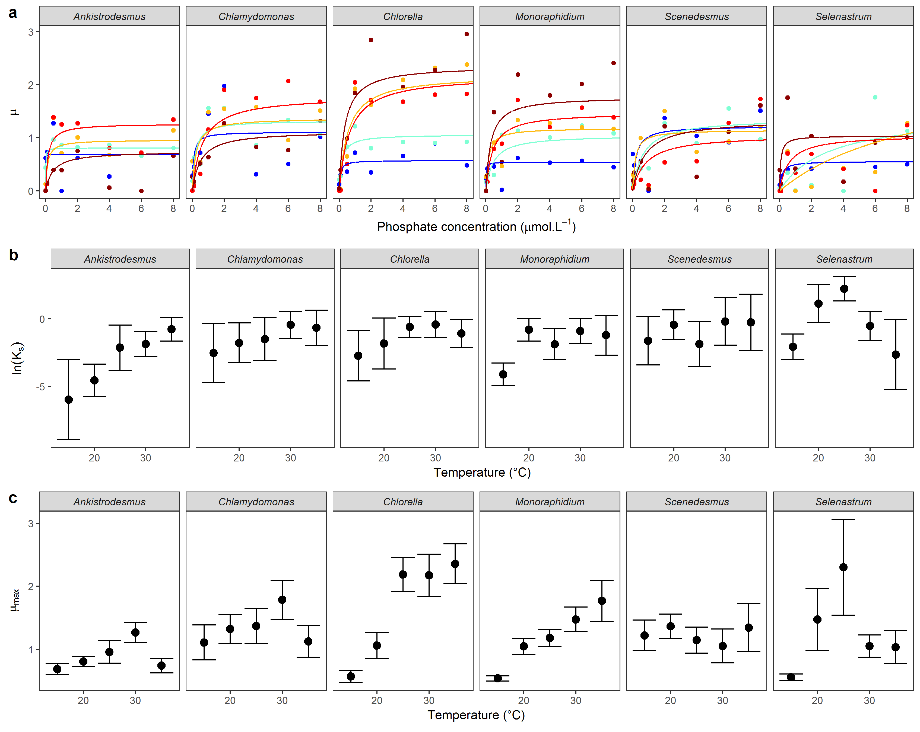

## **Fig 1**:

**(a)** Mean Monod curves for each species growth rate. Growth rate as a function of phosphate concentration in the medium (μmol·L-1) and temperature (from blue: 15°C to dark red: 35°C). Points represent the mean of the 3 replicates. Note that the phosphate concentration levels in the experiment go from 0.01 to 50 μmol·L-1 but the x-axis was cut at 8 μmol·L-1 for clarity. **(b)** Half-saturation coefficient Ks (mean ± 95%CI) **(c)** Maximum growth rate μmax (mean ± 95%CI).

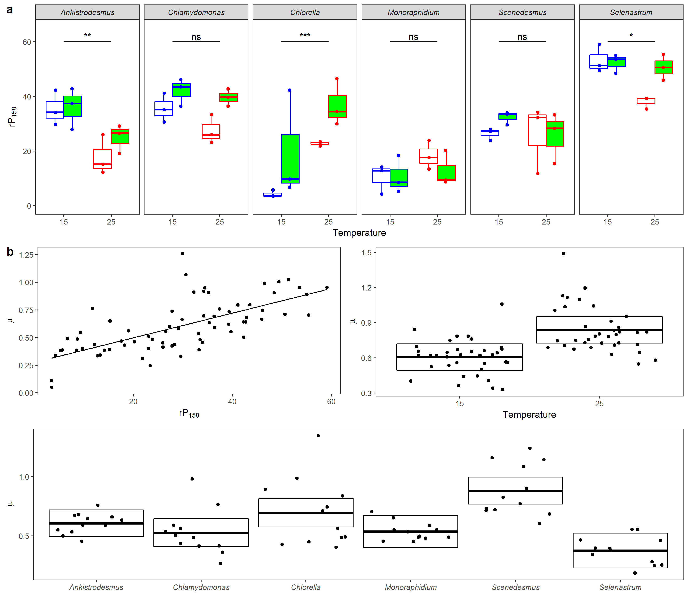

## Fig 2:

**(a)** Rate of electron transport rP at a light intensity of 158 µmol·m-2·s-1 for each species as a function of temperature and phosphate concentration (white, low phosphate concentration, green, high phosphate concentration). Significance levels are given by the contrast analyses between 15 and 25°C by species averaged across phosphate levels (as there is only a simple interaction species by temperature). **(b)** Effect of rP, temperature and species identity on species growth rate.

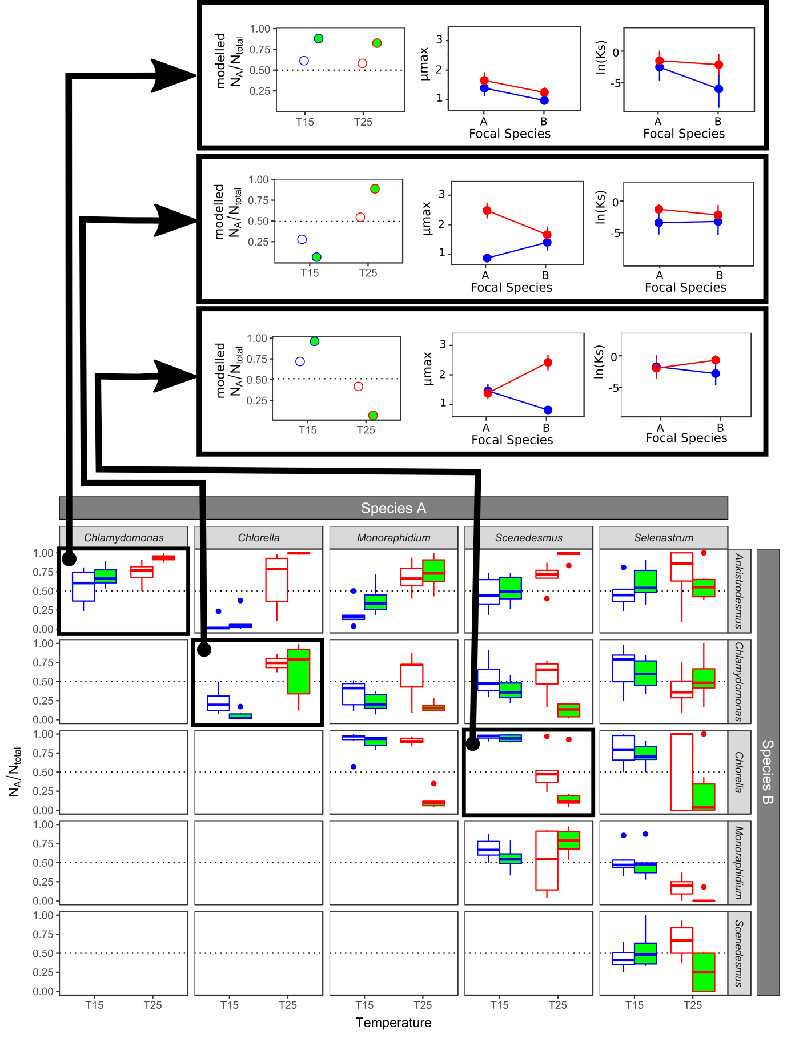

## Fig. 3:

Competition between species. For each pair of species, the proportion of cells from species A over the total number of cells at day 14. Colours represent the temperature of the trial, blue: 15°C, red: 25°C; and fills represent the nutrient conditions of the trial, white: non-saturated nutrient solution (1 μmol·L-1 of phosphate), green, saturated nutrient solution (30 μmol·L-1 of phosphate). Boxplots represent the values of the 6 replicates per condition. The dotted line represents the situation where 50% of the total number of cells pertain to the species A. The three panels outlined in black represent three case studies that are developed above, the competitions between *Ankistrodesmus-Chlamydomonas*, *Chlamydomonas-Chlorella* and *Chlorella-Scenedesmus*. In the developed case study, the first graph represents the outcome of the competition model for each temperature and phosphate level. These outcomes agree with observed competition outcomes. The second and third graphs represent the difference in predicted and half-saturation constant extracted from the Monod models between pairs of species for each temperature, which are fed to the competition models.

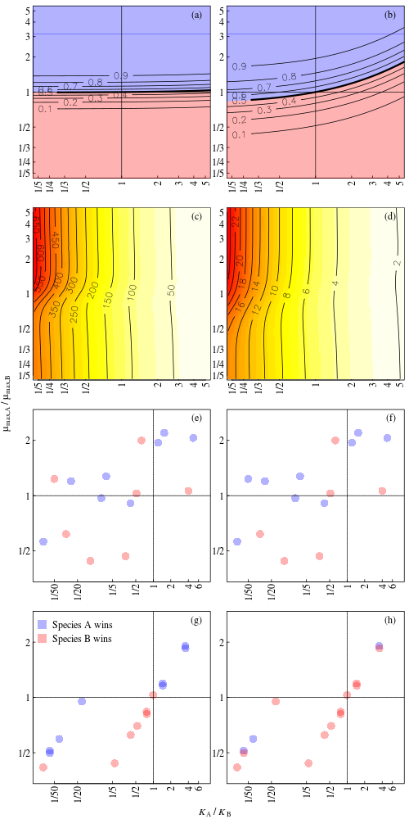

## Fig 4:

Relative importance of mismatches in and in determining competitive outcomes. Panels (a, b) show the proportion of cells belonging to species A after 14 days according to the population model, for a range of mismatches in both traits (see Supplementary Section SX for details). Panels (c, d) show the relative importance of a small increase in the mismatches of the two traits on competitive outcomes. For example, a value of 10 means that a small increase in the ln ratio of has a 10 times greater impact on the competitive outcome than does the same small increase in the ln ratio of . Panels (e-h) show the equivalent experimental results for °C (e, f) and 25°C (g, h), and competitive outcomes (colour of points) refer to the median of six replicates. Panels (a, c, e, g) are for a starting nutrient concentration of 30 μmol·L-1 and (b, d, e, f) are for a starting concentration of 1 μmol·L-1. The legend in (g) applies to all panels except (c, d).

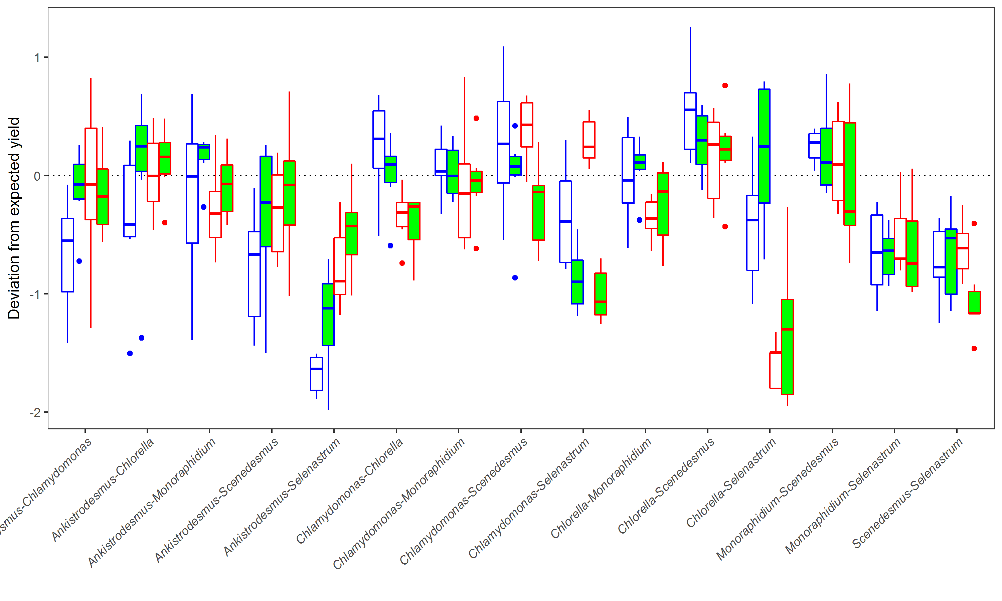

## Fig 5:

Deviation from expected yield (measured as log10(Ntot) – log10(Nto) for each pair of species depending on temperature and phosphate levels. Above the dotted line, the yield in competition is greater than the yield in isolation, suggesting facilitation or niche partitioning, while interactions below the dotted show a negative effect of competition.

# Tables

### Table 1: List of the non-linear mixed effects models investigating growth rate μas a function of phosphate concentration as a function of species identity and temperature level using a Monod function, ordered from lowest to highest AICc. The global model included the interaction between species identity and temperature level as fixed effects on and plus the replicates nested within the temperature and species identity levels as a random effects. The best model is the model with an interaction between species and temperature on and an additive effect of species and temperature on Ks.

|  |  |  |  |  |
| --- | --- | --- | --- | --- |
| **Fixed effects on μmax** | **Fixed effects on ln(Ks)** | **K** | **AICc** | **ΔAICc** |
| 1 + Species * Temperature | 1 + Species * Temperature | 65 | 1204.88 | 0.00 |
| 1 + Species * Temperature | 1 + Species + Temperature | 45 | 1211.79 | 6.92 |
| 1 + Species * Temperature | 1 + Species | 41 | 1215.09 | 10.21 |
| 1 + Species * Temperature | 1 | 36 | 1215.79 | 10.91 |
| 1 + Species * Temperature | 1 + Temperature | 40 | 1217.37 | 12.50 |
| 1 + Species + Temperature | 1 + Species + Temperature | 25 | 1263.74 | 58.87 |
| 1 + Species + Temperature | 1 + Species * Temperature | 45 | 1263.81 | 58.93 |
| 1 + Temperature | 1 + Species * Temperature | 40 | 1264.28 | 59.40 |
| 1 + Temperature | 1 + Species + Temperature | 20 | 1265.52 | 60.65 |
| 1 + Species + Temperature | 1 | 16 | 1265.54 | 60.67 |
| 1 + Species + Temperature | 1 + Species | 21 | 1265.6 | 60.73 |
| 1 + Species + Temperature | 1 + Temperature | 20 | 1266.47 | 61.59 |
| 1 + Temperature | 1 + Species | 16 | 1267.06 | 62.19 |
| 1 + Temperature | 1 | 11 | 1267.07 | 62.20 |
| 1 + Temperature | 1 + Temperature | 15 | 1268.04 | 63.16 |
| 1 | 1 + Species * Temperature | 36 | 1268.24 | 63.36 |
| 1 | 1 + Species + Temperature | 16 | 1270.13 | 65.25 |
| 1 | 1 + Species | 12 | 1270.35 | 65.47 |
| 1 | 1 | 7 | 1270.92 | 66.04 |
| 1 + Species | 1 + Species * Temperature | 41 | 1271.04 | 66.16 |
| 1 + Species | 1 + Species | 17 | 1271.68 | 66.81 |
| 1 + Species | 1 + Species + Temperature | 21 | 1271.91 | 67.03 |
| 1 + Species | 1 | 12 | 1272.35 | 67.47 |
| 1 + Temperature | 1 + Temperature | 11 | 1273.04 | 68.16 |
| 1 + Species | 1 + Temperature | 16 | 1274.72 | 69.84 |

### **Table 2:** Impact of phosphate concentration, temperature and species identity on light acclimated rP at 158 µmol m-2 s-1 light intensity. We fitted a global linear model including both phosphate concentration, temperature level and species identity and all possible interactions and then ran all possible simpler models from this global model. We kept the model that had the lowest AICc (ΔAICc with the second best model, 2.76). We present the results of a type II anova. The model explained 0.74 of the variance (adjusted R2).

|  |  |  |  |  |
| --- | --- | --- | --- | --- |
|  | **Sum.sq** | **Df** | **F** | **P** |
| Species identity | 9092 | 5 | 33.85 | >0.001 |
| Phosphate level | 576 | 1 | 10.73 | 0.0002 |
| Temperature level | 38 | 1 | 0.71 | 0.404 |
| Species: Temperature | 1963 | 5 | 7.31 | >0.001 |

### Table 3: Impact of light acclimated rP, phosphate and temperature on species growth. We fitted a linear model including rP, phosphate level, temperature level and species identity and then ran all possible simpler models from this global model. We didn’t fit interactions as the model would be overparametrised. We kept the model that had the lowest AICc (ΔAICc with the second best model, 2.64). We present the results of a type II anova. The model explained 0.55 of the variance (adjusted R2).

|  |  |  |  |  |
| --- | --- | --- | --- | --- |
|  | **Sum.sq** | **Df** | **F** | **P** |
| Species identity | 1.51 | 5 | 9.20 | >0.001 |
| Temperature level | 0.96 | 1 | 29.17 | >0.001 |
| rP158 | 0.71 | 1 | 21.59 | >0.001 |



### Table 4: Proportion of competitive outcomes correctly predicted by mismatches in individual photosynthetic capacity (rP158), (the growth rate from the Buchanan model at each temperature and nutrient concentration combination), (maximum growth rate at saturating nutrient concentrations from the Monod model), (where a lower is assumed to be beneficial), and both and (using the population model), for all competitions, and by subsets (by temperature, by nutrient concentration, and by species where only competitions involving a specific species are included). P values refer to the model results and are obtained by randomisation (see Supplementary Information Section XXX). For the experimental data, we used the median value of the proportion of cells of a competitor across the six replicates.

|  |  |  |  |  |  |  |  |
| --- | --- | --- | --- | --- | --- | --- | --- |
| **Subset** | **rP158** |  | **Slope** | **SE** | **Model** | **P** | **N** |
| *Full dataset* | | | | | | | |
|  | 0.70 | 0.62 | 0.60 | 0.37 | 0.65 | 0.04 | 60 |
| *By temperature* | | | | | | | |
| °C | 0.80 | 0.67 | 0.57 | 0.43 | 0.67 | 0.09 | 30 |
| °C | 0.60 | 0.57 | 0.63 | 0.30 | 0.63 | 0.12 | 30 |
| *By nutrient concentration* | | | | | | | |
| μmol·L-1 | 0.70 | 0.57 | 0.60 | 0.40 | 0.67 | 0.03 | 30 |
| μmol·L-1 | 0.70 | 0.67 | 0.60 | 0.33 | 0.63 | 0.09 | 30 |
| *By species* | | | | | | | |
| *Ankistrodesmus* | 0.90 | 0.45 | 0.85 | 0.35 | 0.80 | 0.04 | 20 |
| *Chlamydomonas* | 0.75 | 0.65 | 0.60 | 0.30 | 0.70 | 0.05 | 20 |
| *Chlorella* | 0.70 | 0.85 | 0.70 | 0.30 | 0.75 | 0.09 | 20 |
| *Monoraphidium* | 0.60 | 0.65 | 0.50 | 0.50 | 0.65 | 0.06 | 20 |
| *Scenedesmus* | 0.80 | 0.70 | 0.60 | 0.30 | 0.60 | 0.13 | 20 |
| *Selenastrum* | 0.45 | 0.40 | 0.35 | 0.45 | 0.40 | 0.75 | 20 |

### Table 6: Impact of temperature, phosphate level and pair of species identity on the deviation from the expected yield calculated as the logarithm of the observed total density in competition minus the logarithm of the expected total density when grown in isolation (log10(Ntot) -log10(Ntot)). We fitted a linear model including the three-way interaction between pair identity, temperature and nutrient concentration and derived all simpler models. We kept the model that had the lowest AICc (ΔAICc with the second best model, 3.05). We present the results of a type II Anova. The model explained 0.53 of the variance (adjusted R2).

|  |  |  |  |  |
| --- | --- | --- | --- | --- |
|  | **Sum.sq** | **Df** | **F** | **p** |
| Pair identity | 48.95 | 14 | 19.67 | <0.001*** |
| Phosphate level | >0.001 | 1 | >0.001 | 0.980 |
| Temperature level | 0.33 | 1 | 1.87 | 0.171 |
| Pair identity * phosphate | 10.48 | 14 | 4.21 | <0.001*** |
| Pair identity * temperature | 18.26 | 14 | 7.34 | <0.001*** |
| Phosphate * temperature | 0.89 | 1 | 5.01 | 0.026* |

# Supplementary Information

**S1. Significance of binary outcomes predicted by the population model**

To quantify the significance of the model’s ability to predict competitive outcomes, we ran the population model 10,000 times, sampling the values of and independently with replacement from the pool of available values. When assessing model performance for a particular subset, for example, for competitions at °C, and were sampled independently from all values at °C only. The analysis produced 10,000 values of proportion of competitive outcomes correctly predicted, for the 10,000 random parameter combinations. Figure S1 shows an example distribution, for the full dataset. The proportion of runs that correctly predicted a greater number of competitive outcomes than the model with the real values of and is then given as the P value in Table XXX. Therefore, P=0.05 means that 500 out of 10,000 random parameter combinations correctly predicted a greater proportion of competitive outcomes.

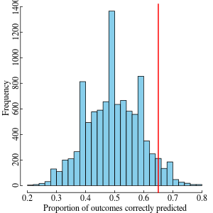

## Figure S1:

Histogram of the proportion of competitive outcomes correctly predicted for the 10,000 random combinations of and . The red line indicates the performance of the model with the real values of and . Here, there were 427 random parameter combinations that correctly predicted a greater number of competitive outcomes (P = 0.04 in Table 4).

**S2. Simulations to compare the relative effects of mismatches**

We use the population model to assess the relative importance of mismatches in and for determining the competitive outcome (Figure X in the main text). Mismatches are here defined as the ratios in the two traits between the two competitors. Ratios allow for direct comparison of the relative importance of mismatches in and despite the different units. We assumed one competitor to have values of and close to the respective median values across all species and treatments ( and respectively), while the second competitor’s and values were chosen such that the ln ratio parameter space was evenly sampled. Results were insensitive to the choice of values for the fixed competitor. The reason to use ln ratios is to ensure that a ratio and its inverse are equidistant from a ratio of one. For all combinations of mismatches in traits we ran the population model and extracted the proportion of total cells belonging to competitor A at day 14, for different starting nutrient concentrations (Figure Xa, b in the main text). As in the experiments, both species had a starting population density of 100 cells·mL-1.

To compare the relative importance of mismatches in the two traits directly, we quantified by how much the competitive outcome changed due to a small increase in the ln ratio of and due to the same small increase in the ln ratio of , and took their ratio. For example, a value of 10 means that a small increase in the mismatch in had a 10 times greater effect on the competitive outcome than did the same small increase in the mismatch in (Figure Xc, d in the main text).

**S2. Additional results**

## Figure S1: Experimental design

6 phytoplankton species

Isolates 🡪Species discrimination function 🡪Applied to pairs of species 🡪Species identity 🡪 **competition coefficients**

25°C

Pair of species

Isolate

**Competition experiment**

For each pair of species



15°C

Acclimated photosynthesis

25°C

15°C

*μmax*

*μ*

Growth rate

[P]*1*

*Ks1*

*Ks1*

*μmax*

**Temperature-and-nutrient-dependent growth rate**

For each species

**Acclimated physiology**

For each species

35°C

30°C

25°C

20°C

15°C

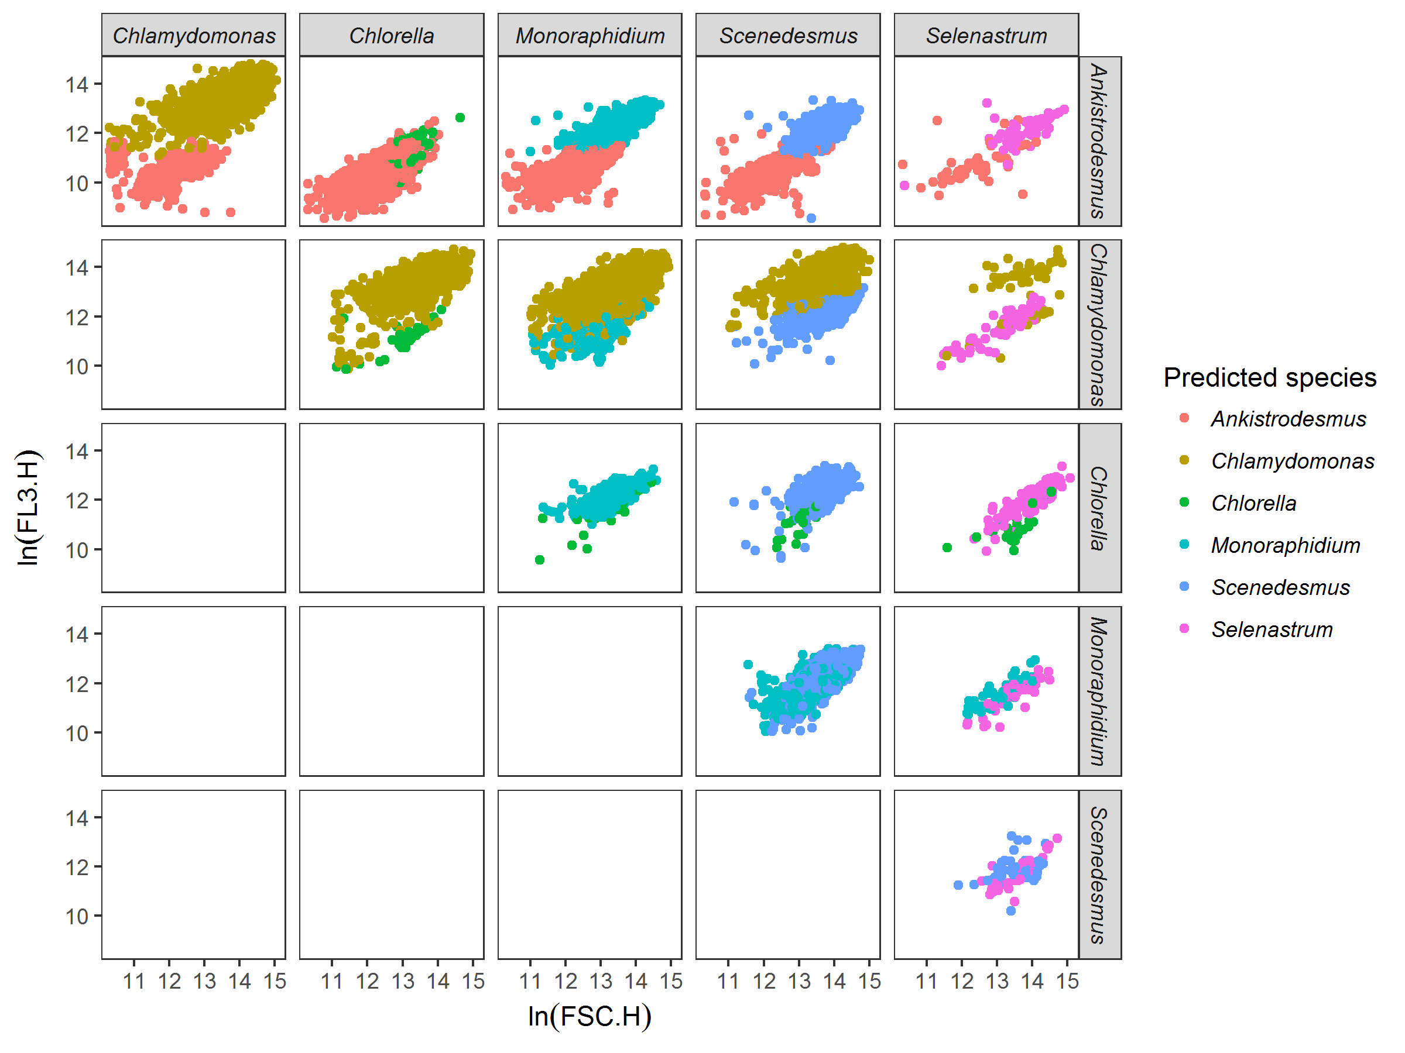

## Figure S2:

Example of discrimination between species among pairs of species, here for species grown at 15°C in saturating nutrient conditions after 14 days of experiment. Each dot represents a cell, here mapped on FSC.H (size proxy) and FL3.H (chlorophyll a proxy) characteristics from the flow cytometer. Colours represent the species predicted by the discrimination algorithm. The discrimination algorithm is a linear discriminant analysis trained with flow cytometer data (FSC.H, FSC.A, SSC.H, SSC.A, FL1.H, FL1.A, FL2.H, FL2.A, FL3.H, FL3.A, FL4.H, and FL4.A) from the species grown in isolates at the same temperature and nutrient conditions. For example, *Chlamydomonas* outcompetes *Chlorella* in these nutrient and temperature conditions.

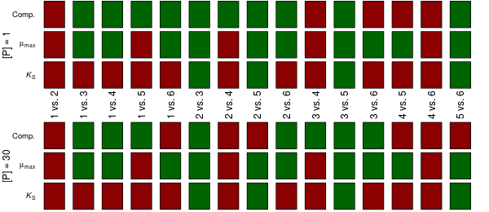

## Figure S3:

Reversals of competitive outcomes and traits due to temperature. Red boxes mean no reversal, while green boxes mean a reversal was observed between 15°C and 25°C. The different columns are for different competitions (e.g., species 1 vs. species 2). ‘Comp.’ refers to the experimentally observed competitive outcome, while and refer to species’ traits that define the Monod curve. Results are shown for the two nutrient concentrations separately. For example, for species 1 vs. species 2, no reversals were observed in competitive outcomes or traits, while for species 1 vs. species 3, a reversal was observed in both the competitive outcome and (at both nutrient concentrations), but not in .

## Table S1:

**Detailed information about the 6 species**

|  |  |  |  |  |
| --- | --- | --- | --- | --- |
| **Species name** | **Class** | **Order** | **Strain** | **Origin** |
| *Ankistrodesmus nannoselene*  Skuja (1948) | Chlorophyceae | Sphaeropleales | CCAP 202/6A | Siggeforsajon, Sweden |
| *Chlamydomonas moewusii*  Gerlof (1940) | Chlorophyceae | Chlamydomonadales | CCAP 11/5A | Freshwater |
| *Chlorella sorokiniana*  Shihira & Krauss (1965) | Trebouxiophyceae | Chlorellales | CCAP 211/8K | Austin, Texas, USA |
| *Monoraphidium minutum* (Nägeli)  Komarkova-Legnerova (1969) | Chlorophyceae | Sphaeropleales | CCAP 278/3 | Texas, USA |
| *Scenedesmus obliquus* (Turpin) Kützing (1833) | Chlorophyceae | Sphaeropleales | CCAP 276/3B | Lund, Sweden |
| *Selenastrum capricornutum*  Printz (1913) | Chlorophyceae | Sphaeropleales | CCAP 278/4 | Akershus, Norway |

## Table S2:

Phosphate concentration levels in µmol·L-1 and µg·L-1, and associated amounts of COMBO medium without potassium phosphate dibasic (P- COMBO) and normal COMBO medium (P+ COMBO) mixed together in 40 mL nunclons to obtain the phosphate concentration levels.

|  |  |  |  |  |  |  |  |  |  |  |  |  |  |
| --- | --- | --- | --- | --- | --- | --- | --- | --- | --- | --- | --- | --- | --- |
| Phosphate concentration (µmol·L-1 ) | 50 | 40 | 30 | 20 | 10 | 8 | 6 | 4 | 2 | 1 | 0.5 | 0.1 | 0.01 |
| Phosphate concentration (µg·L-1 ) | 4750 | 1960 | 2850 | 1900 | 950 | 760 | 570 | 380 | 190 | 95 | 47.5 | 9.5 | 0.95 |
| Amount of P+ COMBO (mL) | 40 | 32 | 24 | 16 | 8 | 6.4 | 4.8 | 3.2 | 1.6 | 0.8 | 0.4 | 0.08 | 0.008 |
| Amount of P- COMBO (mL) | 0 | 8 | 16 | 24 | 32 | 33.6 | 35.2 | 36.8 | 38.4 | 39.2 | 39.6 | 40 | 40 |

## Table S3:

A: Proportion of correct assignations for each discrimination method (LDA: linear discriminant analysis, Random Forest analysis, CART: classification and regression tree) summarised by phosphate and nutrient conditions for all pair of species. B: Proportion of correct assignations for each discrimination method summarised by pair of species for all nutrient and thermal conditions. C: Proportion of correct assignations for each discrimination method summarised by species for all nutrient and thermal conditions

A

|  |  |  |  |  |
| --- | --- | --- | --- | --- |
| **Temperature** | **Nutrient** | **LDA** | **Random forest** | **CART** |
| 15 | 1 | 0.79 | 0.68 | 0.64 |
| 15 | 30 | 0.85 | 0.8 | 0.76 |
| 25 | 1 | 0.7 | 0.69 | 0.68 |
| 25 | 30 | 0.64 | 0.66 | 0.62 |
| **Mean** | | **0.75** | **0.71** | **0.68** |

B

|  |  |  |  |
| --- | --- | --- | --- |
| **Species** | **LDA** | **Randomforest** | **CART** |
| *Ankistrodesmus* | 0.91 | 0.86 | 0.72 |
| *Chlamydomonas* | 0.93 | 0.93 | 0.81 |
| *Chlorella* | 0.85 | 0.86 | 0.67 |
| *Monoraphidium* | 0.84 | 0.78 | 0.65 |
| *Scenedesmus* | 0.83 | 0.77 | 0.61 |
| *Selenastrum* | 0.70 | 0.68 | 0.48 |
| **Mean** | **0.84** | **0.81** | **0.66** |

C

|  |  |  |  |
| --- | --- | --- | --- |
| **Pair of species** | **LDA** | **Randomforest** | **CART** |
| *Ankistrodesmus-Chlamydomonas* | 1 | 1 | 0.94 |
| *Ankistrodesmus-Chlorella* | 0.91 | 0.88 | 0.73 |
| *Ankistrodesmus-Monoraphidium* | 0.87 | 0.74 | 0.71 |
| *Ankistrodesmus-Scenedesmus* | 0.95 | 0.93 | 0.71 |
| *Ankistrodesmus-Selenastrum* | 0.82 | 0.73 | 0.52 |
| *Chlamydomonas-Chlorella* | 0.96 | 0.96 | 0.79 |
| *Chlamydomonas-Monoraphidium* | 0.96 | 0.97 | 0.86 |
| *Chlamydomonas-Scenedesmus* | 0.94 | 0.92 | 0.74 |
| *Chlamydomonas-Selenastrum* | 0.78 | 0.8 | 0.74 |
| *Chlorella-Monoraphidium* | 0.83 | 0.85 | 0.7 |
| *Chlorella-Scenedesmus* | 0.86 | 0.84 | 0.65 |
| *Chlorella-Selenastrum* | 0.67 | 0.76 | 0.48 |
| *Monoraphidium-Scenedesmus* | 0.88 | 0.69 | 0.63 |
| *Monoraphidium-Selenastrum* | 0.68 | 0.67 | 0.33 |
| *Scenedesmus-Selenastrum* | 0.53 | 0.46 | 0.34 |
| **Mean** | **0.84** | **0.81** | **0.66** |